Ex7 – Creating MYSQL Instances

# Nithin Prasath C – 22BCS081

## AIM:

To create and configure a MySQL database instance in Amazon Web Services (AWS) using the RDS (Relational Database Service) platform, enabling secure and scalable cloud-based database management.

## DESCRIPTION:

This lab task involves creating a fully managed MySQL instance in AWS RDS. The steps include logging into the AWS Management Console, setting up a new MySQL instance, selecting instance class and storage options, configuring security (VPC, subnets, and security groups), and enabling multi-AZ deployments for high availability. Once the instance is created, you will configure the database with appropriate credentials and connect to it using MySQL Workbench or a similar SQL client. The task demonstrates the ability to provision, configure, and manage MySQL databases in a cloud environment, while ensuring security and availability using AWS RDS.

## OUTPUT:

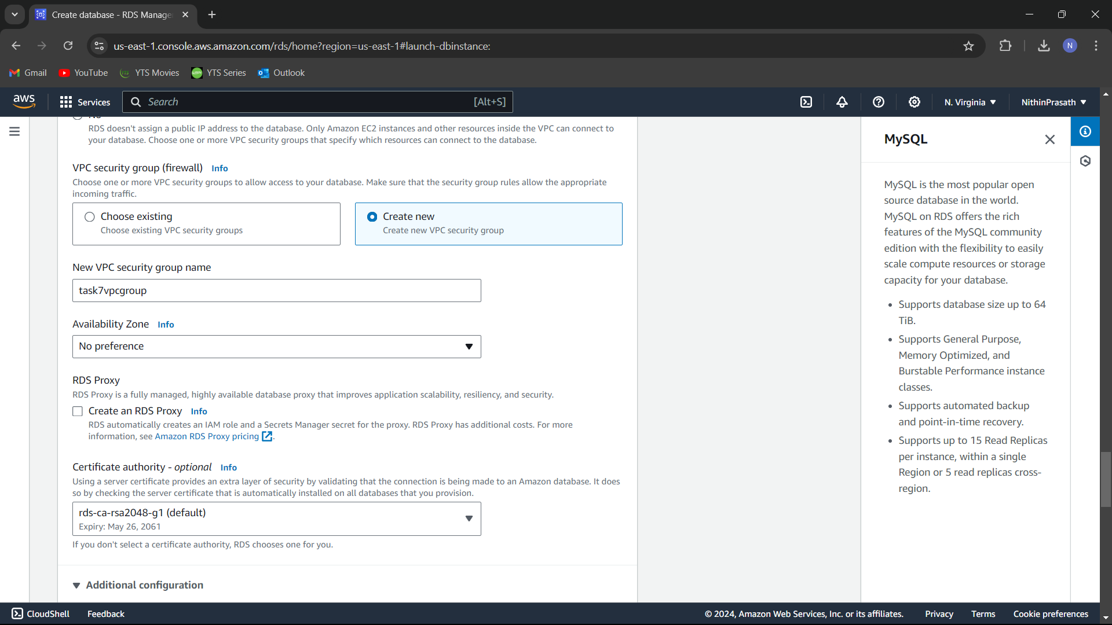

## RESULT:

Successfully created a MySQL instance in AWS RDS. The database is now running, secure, and accessible. Screenshots are attached to demonstrate each step of the configuration process, from instance setup to successful connection using a MySQL client.